**Description Margin**

example

margin(sys) plots the Bode response of sys on the screen and indicates the gain and phase margins on the plot. Gain margins are expressed in dB on the plot.

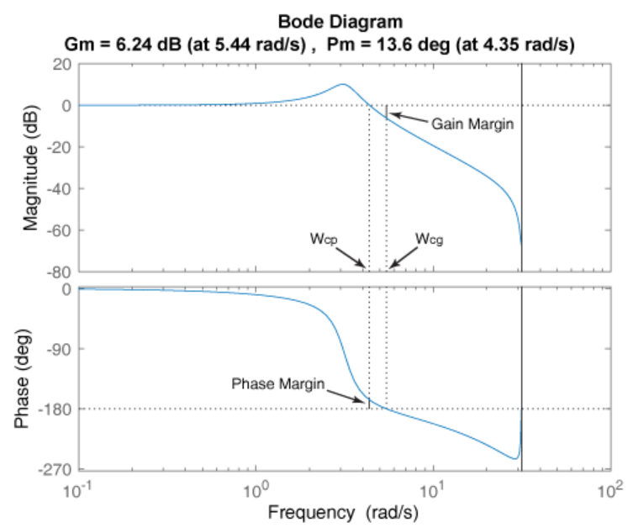

Solid vertical lines mark the gain margin and phase margin. The dashed vertical lines indicate the locations of Wcp, the frequency where the phase margin is measured, and Wcg, the frequency where the gain margin is measured. The plot title includes the magnitude and location of the gain and phase margin.

Gm and Pm of a system indicate the relative stability of the closed-loop system formed by applying unit negative feedback to sys, as shown in the following figure.

Gm is the amount of gain variance required to make the loop gain unity at the frequency Wcg where the phase angle is –180° (modulo 360°). In other words, the gain margin is 1/g if g is the gain at the –180° phase frequency. Similarly, the phase margin is the difference between the phase of the response and –180° when the loop gain is 1.0.

The frequency Wcp at which the magnitude is 1.0 is called the unity-gain frequency or gain crossover frequency. Usually, gain margins of three or more combined with phase margins between 30° and 60° result in reasonable tradeoffs between bandwidth and stability.

Example 1. [Gm,Pm,Wcg,Wcp] = margin(sys) returns the gain margin Gm in absolute units, the phase margin Pm, and the corresponding frequencies Wcg and Wcp, of sys. Wcg is the frequency where the gain margin is measured, which is a –180° phase crossing frequency. Wcp is the frequency where the phase margin is measured, which is a 0-dB gain crossing frequency. These frequencies are expressed in radians/TimeUnit, where TimeUnit is the unit specified in the TimeUnit property of sys. When sys has several crossovers, margin returns the smallest gain and phase margins and corresponding frequencies.

Example 2. [Gm,Pm,Wcg,Wcp] = margin(mag,phase,w) derives the gain and phase margins from frequency response data. Provide the gain data mag in absolute units, and phase data phase in degrees. You can provide the frequency vector w in any units and margin returns Wcg and Wcp in the same units.

Example 3. [Gm,Pm] = margin(sys,J1,...,JN) returns the gain margin Gm and phase margin Pm of the entries in model array sys with subscripts (J1,...,JN).

Examples

collapse all

**Plot Gain and Phase Margins of Transfer Function**

Open Live Script

For this example, create a continuous transfer function.

sys = tf(1,[1 2 1 0])

sys =

1

---------------

s^3 + 2 s^2 + s

Continuous-time transfer function.

Display the gain and phase margins graphically.

margin(sys)

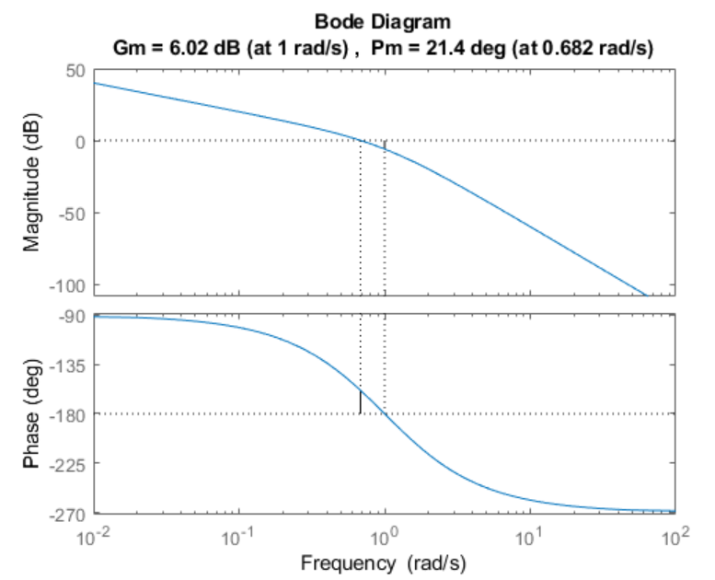

The gain margin (6.02 dB) and phase margin (21.4 deg), displayed in the title, are marked with solid vertical lines. The dashed vertical lines indicate the locations of Wcg, the frequency where the gain margin is measured, and Wcp, the frequency where the phase margin is measured.

**Gain and Phase Margins of Transfer Function**

Open Live Script

For this example, create a discrete-time transfer function.

sys = tf([0.04798 0.0464],[1 -1.81 0.9048],0.1)

sys =

0.04798 z + 0.0464

---------------------

z^2 - 1.81 z + 0.9048

Sample time: 0.1 seconds

Discrete-time transfer function.

Compute the gain margin, phase margin and frequencies.

[Gm,Pm,Wcg,Wcp] = margin(sys)

Gm = 2.0517

Pm = 13.5711

Wcg = 5.4374

Wcp = 4.3544

The results indicate that a gain variation of over 2.05 dB at the gain crossover frequency of 5.43 rad/s would cause the system to be unstable. Similarly a phase variation of over 13.57 degrees at the phase crossover frequency of 4.35 rad/s will cause the system to lose stability.

**Gain and Phase Margins using Frequency Response Data**

Open Live Script

For this example, load the frequency response data of an open loop system, consisting of magnitudes (m) and phase values (p) measured at the frequencies in w.

load('openLoopFRD.mat','p','m','w');

Compute the gain and phase margins.

[Gm,Pm,Wcg,Wcp] = margin(m,p,w)

Gm = 0.6249

Pm = 48.9853

Wcg = 1.2732

Wcp = 1.5197